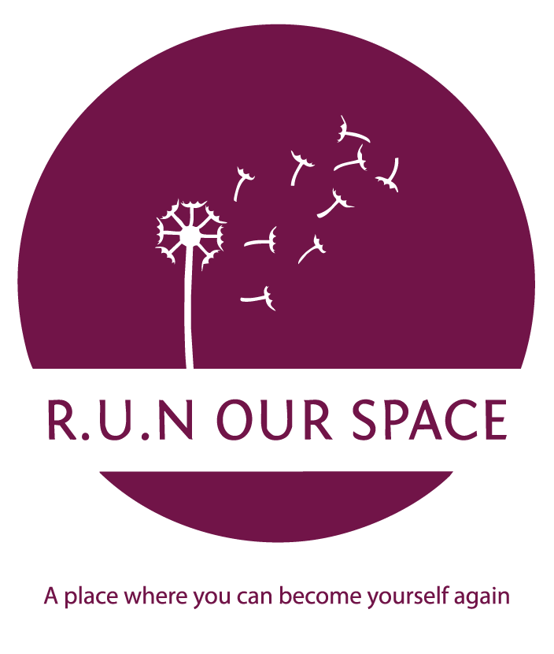

R.U.N. Our Space CIC: Professional Referral Form
Protecting Vulnerable Communities

Section 1: Professional Details
- Referring Agency: __________________________________________________
- Contact Name & Role: _______________________________________________
- Email / Direct Phone: _______________________________________________
- Date of Referral:

Section 2: Client Information
- Name of Woman: ____________________________________________________
- Preferred Contact Method: [ ] Phone [ ] Email [ ] Text Only (for safety)
- Does she have safe access to her phone? [ ] Yes [ ] No
Please indicate if it is safe to; call, text or email her:
____________________________________________________

Contact details: ____________________________________________________

Section 3: Barriers & Risks (Confidential)
To help us provide the right "Middle Gap" support, please indicate current challenges:
- [ ] Domestic Abuse / Sexual Violence
- [ ] Mental Health (Anxiety, Depression, Low Self-Esteem)
- [ ] Social Isolation / Risk of Poverty
- [ ] Risk of Exploitation or Targeted Harassment
- Specific Safety Concerns: (e.g., known perpetrator in the area, housing crisis)

Section 4: The R.U.N. Pathway
Which stream do you feel would benefit her most initially?
- [ ] Stream 1: We Are More (Emotional healing, arts, social connection)
- [ ] Stream 2: Journey After (Advocacy, CVs, career/education progression)
- [ ] Stream 3: Women Who Lead (Mentoring for her own project ideas)

Section 5: The "Chill Before You Arrive" Buddy Request
- Does the client require a 1:1 coffee shop meeting before visiting the hub? [ ] Yes [ ] No
- Preferred neutral location in Bromsgrove: ______________________________
Professional Declaration:
I have discussed this referral with the client, and she has consented to her details being shared with R.U.N. Our Space CIC for the purpose of support and advocacy.
Signed: _________________________________ Date: ___________________

If there are any problems with the referral or added information that is needed to be shared, please contact Javina Greene.
Recovery.united.network@gmail.com or 07497 082 543
Please send the referral back to us by email.

Javina Greene
Founder, Director and Lead Advocate
For R.U.N Our Space CIC

